**EE-500 Assignment Report**

**Name: Omkar Rajkumar Pabshetwar**

**Course: MECEC**

**Student Id: 18210473**

**Email Id: omkar.pabshetwar2@mail.dcu.ie**

**PART 1: Data Transmission over the WiFi Network**

**Question A**

1. The example script is present in the Assignment_18210473/Question_A_1 directory. ./waf –run is used to run the example. Once the programme is built wifi-example-db.sh file is executed to measure the performance parameters at distance **50 m** and the sim time is 20 seconds. Using the data from shell file script delay, loss and throughput are calculated. The result after running script **wifi-example-sim.cc** is recorded in **DataOfUser1.db** file.

The recoded performance parameters at distance 50m for WiFi-User of original scenario from Wifi-example-sim.cc are shown below:

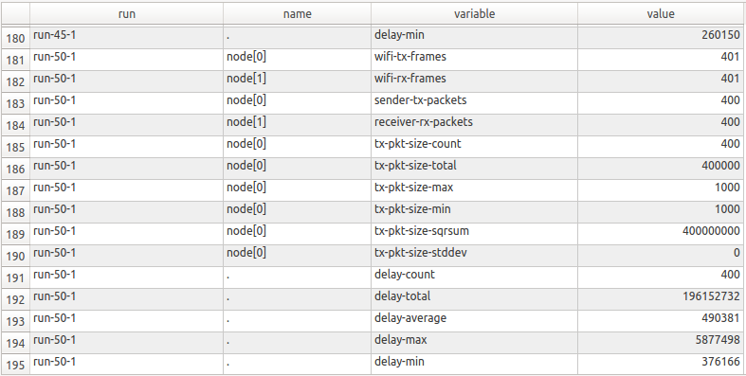

**DataOfUser1.db**

The **Bit-rate** at the interval of 0.05 is **160Kbps or 0.16Mbps**, it is calculated by theoretical value 1000 bytes transmitted in 0.05 seconds which computes [(1000*8)/0.05]=160Kbps=0.16Mbps.

Using Shell command ( ./wifi-example-db.sh) the script inside the file wifi-example-db.sh is executed for distance 50m to calculate and observe the results for average packet loss, average delay and average throughput. The data is observed over the distance ranging from 0 to 200m including the distance 50m and it is understood that packet loss ratio is 0% , for 1000 bytes at an interval of 0.05 seconds gives **average throughput** of **0.16 Mbps = 160.00 Kbps**, the average delay for packet to travel from Wifi AP to Wifi user is reported in DataOfUser.db file. The delay.data file along loss.data and throughput.data files are generated and shows **average delay 490381ns =0.490381 ms.**

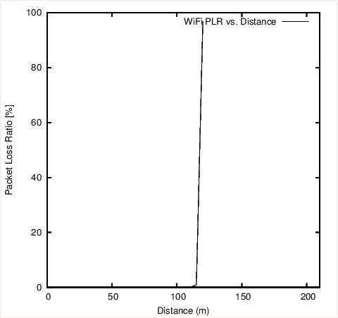 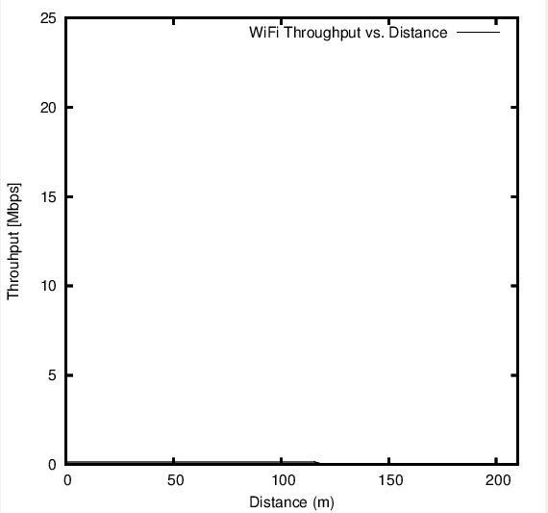

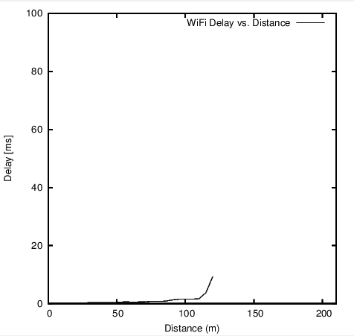 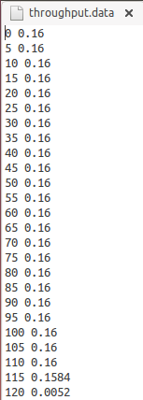 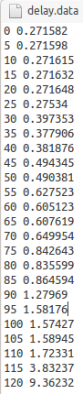 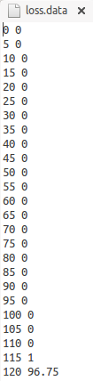

1. The example script is present in the Assignment_18210473/Question_A_2 directory. ./waf –run is used to run the example. In the Second Scenario data transmission is observed at five different bitrate levels: 1Mbps, 5Mbps, 10Mbps, 15Mbps and 20 Mbps respectively for WiFi User 1 traffic by modifying script wifi-example-sim.cc. The same procedure is followed to measure the results for average packet loss, average delay and average throughput by using Shell command ( ./wifi-example-db.sh) for the script inside the file wifi-example-db.sh is executed for distance 50m.

It is seen that performance parameters increases as the bit rate increases; the average PLR and average delay have subsequent increase as the bitrate is changed and increased. The effect is shown below in screenshot captured of the DataOfUser1.db file, throughput.data file and plots of all performance parameters.

1. **The performance parameters for bitrate level 1Mbps that is interval of 0.008 are as follows:**

1.Average Throughput (Kbps): 1000 Kbps

2.Average Delay (second):0.441013ms = 0.0004410 seconds

3.Average PLR between WiFi-AP and WiFi-User1: 3.98

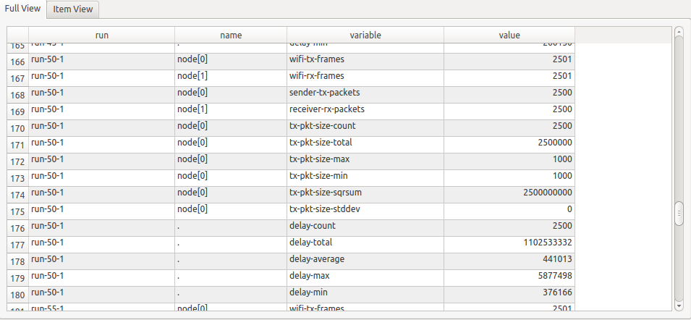

**DataOfUser1.db**

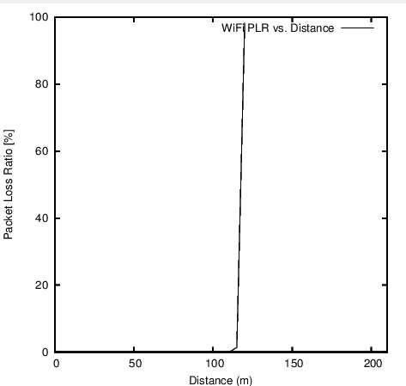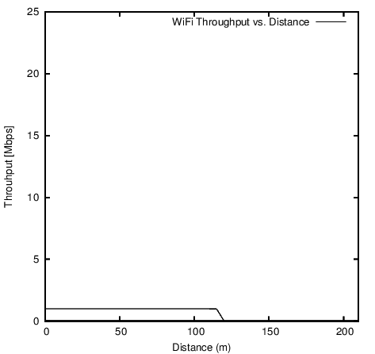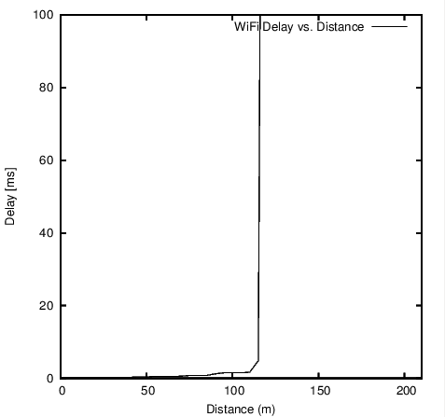

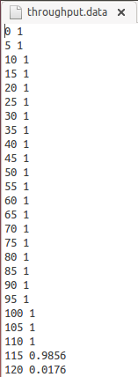 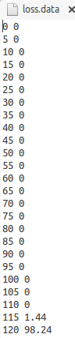 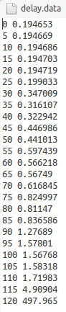

1. **The performance parameters for bitrate level 5Mbps that is interval of 0.0016 are as follows:**

1.Average Throughput (Kbps):5000Kbps

2.Average Delay (second):0.438767ms= 0.000438 seconds

3.Average PLR between WiFi-AP and WiFi-User1: 8.04

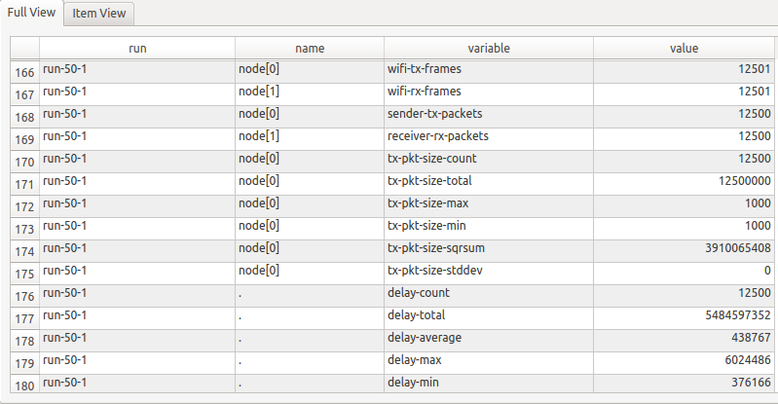

**DataOfUser1.db**

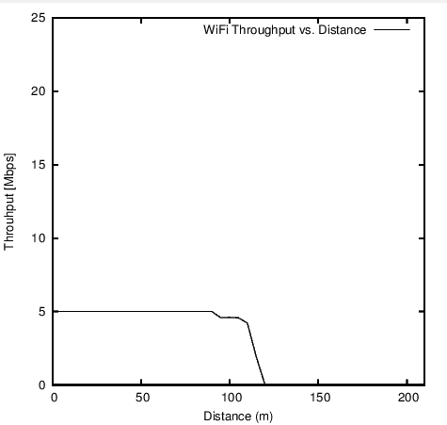 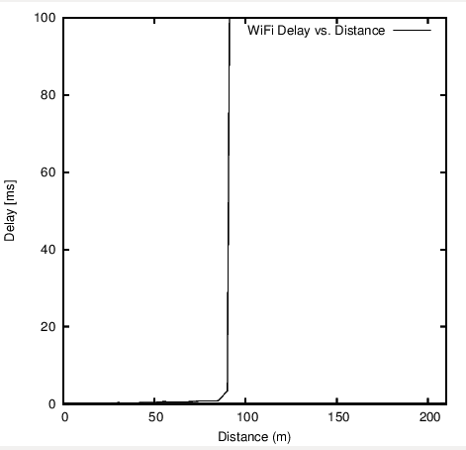

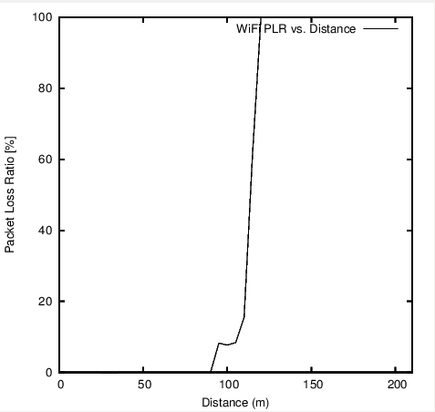 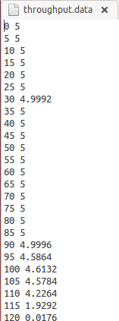 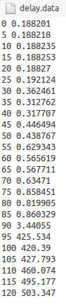 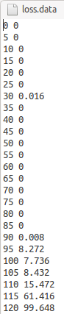

1. **The performance parameters for bitrate level 10Mbps that is interval of 0.0008 are as follows:**

1.Average Throughput (Kbps): 9998 Kbps

2.Average Delay (second):0.497431ms= 0.000497 seconds

3.Average PLR between WiFi-AP and WiFi-User1: 20.056

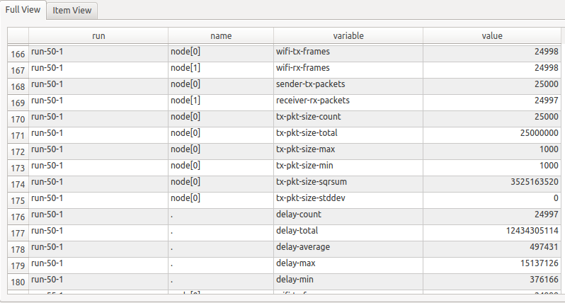

**DataOfUser1.db**

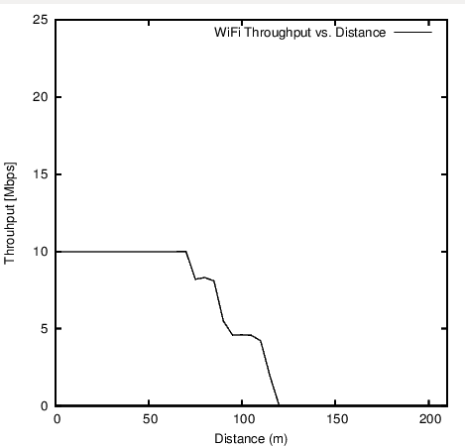 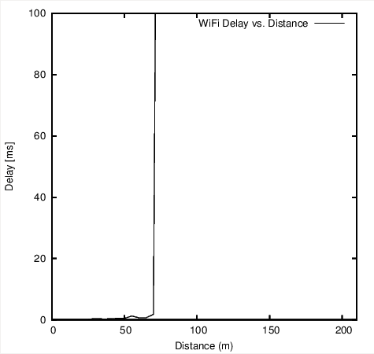

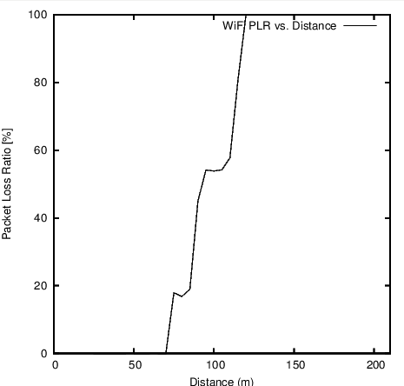 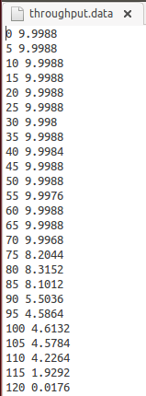 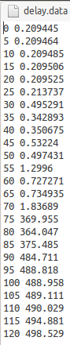 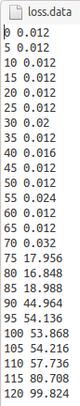

1. **The performance parameters for bitrate level 15Mbps interval of 0.000533 are as follows:**

1.Average Throughput (Kbps): 13747Kbps

2.Average Delay (second):219.6204ms=0.2196 seconds

3.Average PLR between WiFi-AP and WiFi-User1: 31.9381

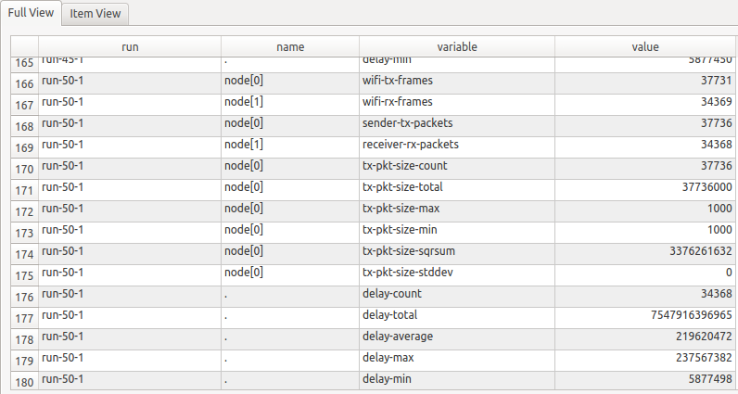

**DataOfUser1.db**

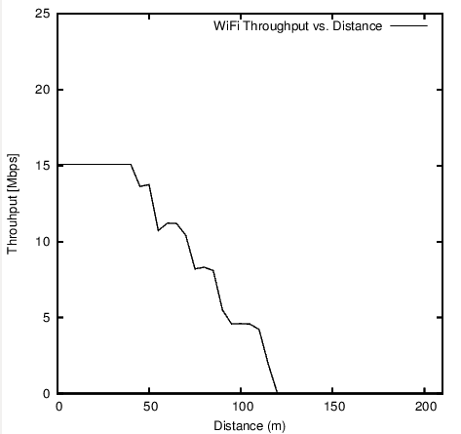 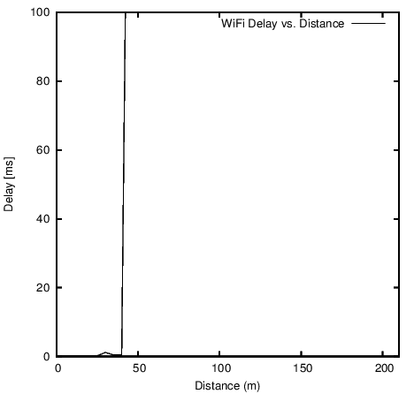

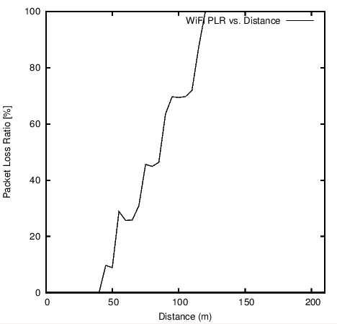 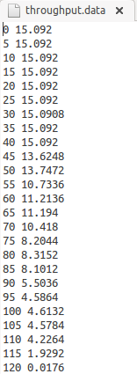 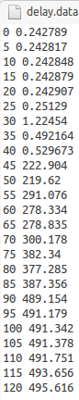 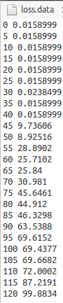

1. **The performance parameters for bitrate level 20Mbps interval of 0.0004 are as follows:**

1.Average Throughput (Kbps): 13747.2 Kbps

2.Average Delay (second): 229.097912ms= 0.2290 seconds

3.Average PLR between WiFi-AP and WiFi-User1: 41.55

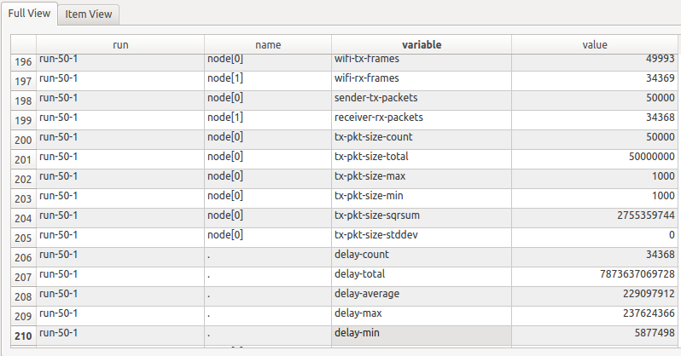

**DataOfUser1.db**

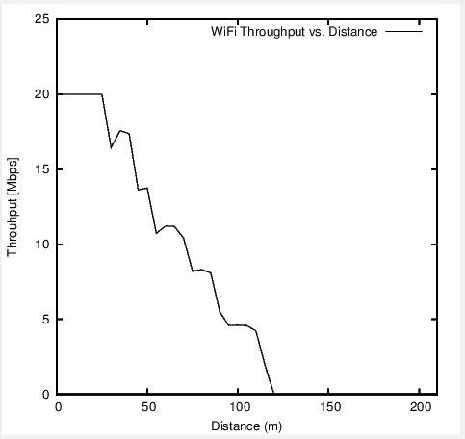 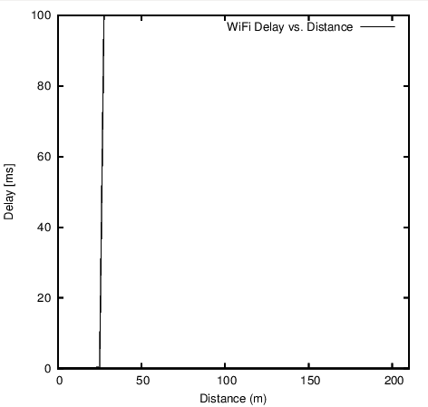

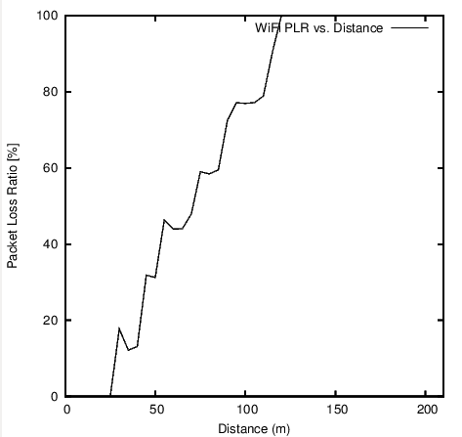 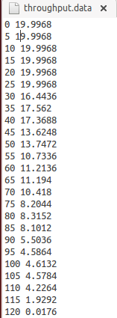 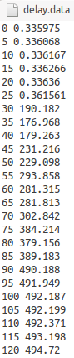 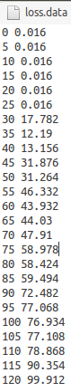

**Question B**

The example script is present in the Assignment_18210473/Question_B directory. ./waf –run is used to run the example. The Question B is implemented by changing distance to different values between 0 to 200 metres (keeping step of 20m). The data transmission is test over the points 0,20,40,50,60,80,100,120,140,160,180,200. To measure the performance parameters same procedure is followed after successful run of Shell command ( ./wifi-example-db.sh). The data is observed over the distance ranging from 0 to 200m and it is understood that packet loss ratio is 0% , for the distance between 0 to 100m and 96.75+ after 100m. 1000 bytes at an interval of 0.05 seconds gives **average throughput** of **0.14065 Mbps = 140.65Kbps**, the average delay for packet to travel from Wifi AP to Wifi user is reported in DataOfUser.db file. The delay.data file along loss.data and throughput.data files are generated and shows **average delay 1.7240 ms.**

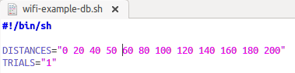

wifi-example-db.sh-distances (0-200m)

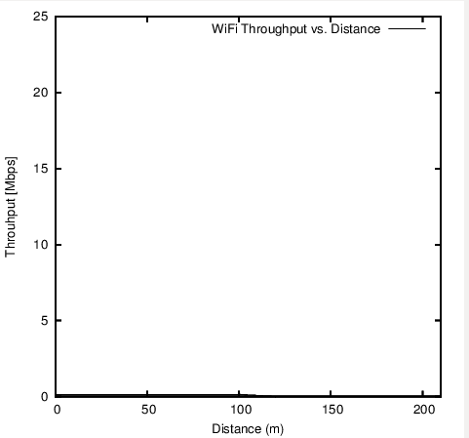 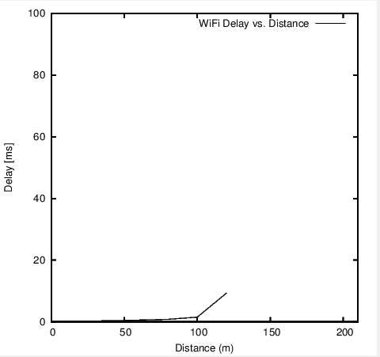

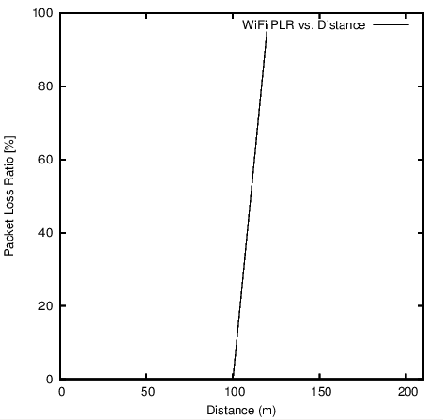 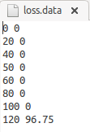 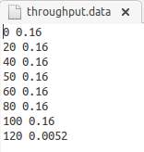 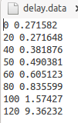

**Question C**

1. The example script is present in the Assignment_18210473/ Question_C/ Question_C_1 directory. ./waf –run is used to run the example. Once the programme is built wifi-example-db.sh file is executed 2 times to measure the performance parameters at distance **50 m,** firstfor User1 and then followed for User 2 . Using the data from shell file script delay, loss and throughput are calculated. The result after running script **wifi-example-sim.cc** is recorded in **DataOfUser1.db** file for User 1 and **DataOfUser2.db** file for User 2. There is 0% packet loss ratio in data transmission for both users, average throughput is 1000 Kbps for both users. There is increase in average delay for user 2 as compared to user 1.

The recorded performance parameters at distance 50m for WiFi-User of original scenario from Wifi-example-sim.cc are shown below:

1. **Results for User 1:**

The data is observed over the distance ranging from 0 to 200m and it is understood that packet loss ratio is 0%. 1000 bytes at an interval of 0.05 seconds gives **average throughput** of **1 Mbps = 1000 Kbps**, the average delay for packet to travel from Wifi AP to Wifi user is reported in DataOfUser.db file. The delay.data file along loss.data and throughput.data files are generated and shows **average delay 443751ns =0.443751ms.**

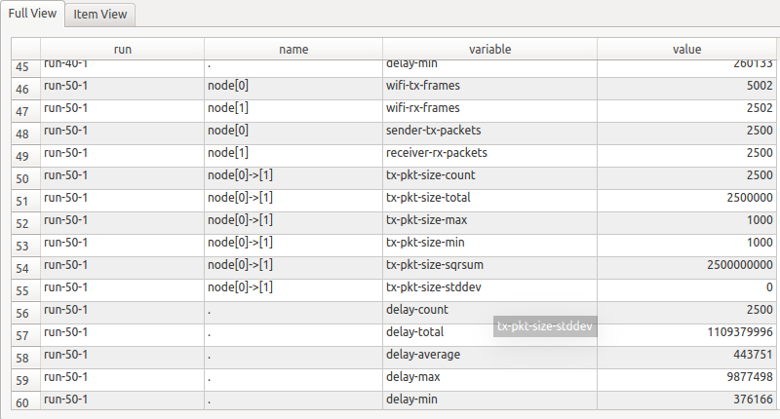

**DataOfUser1.db**

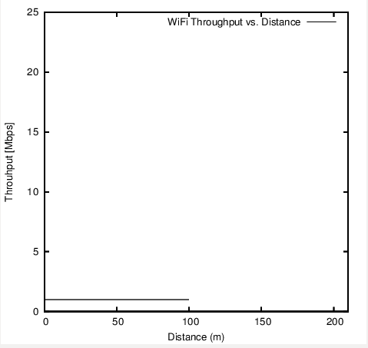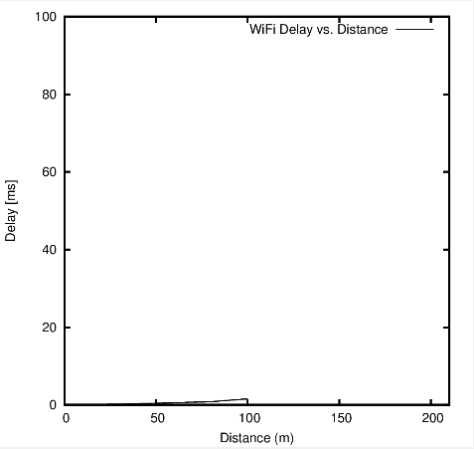

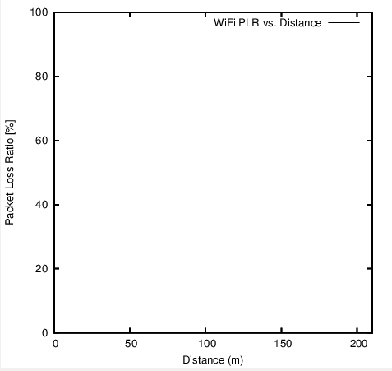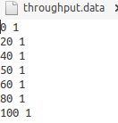 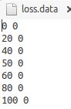 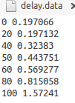

1. **Results for User 2:**

The data is observed over the distance ranging from 0 to 200m and it is understood that packet loss ratio is 0%. 1000 bytes at an interval of 0.05 seconds gives **average throughput** of **1 Mbps = 1000 Kbps**, the average delay for packet to travel from Wifi AP to Wifi user is reported in DataOfUser.db file. The delay.data file along loss.data and throughput.data files are generated and shows **average delay 1033712ns =1.033712ms.**

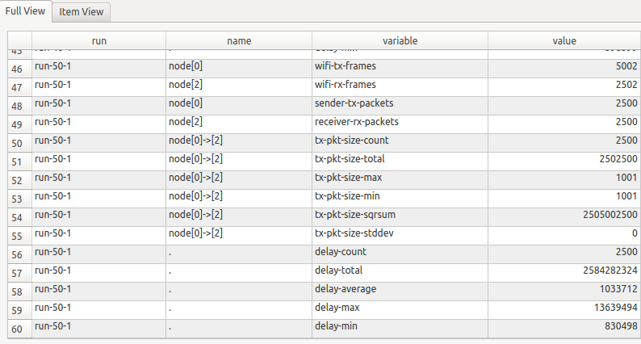

**DataOfUser2.db**

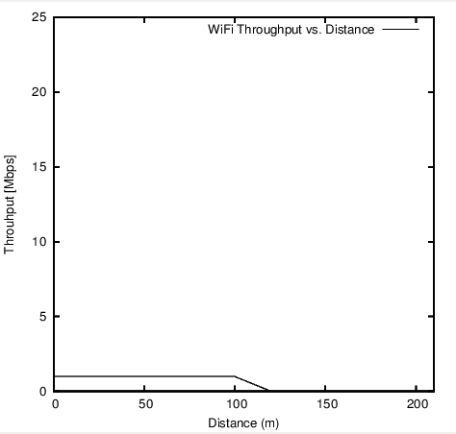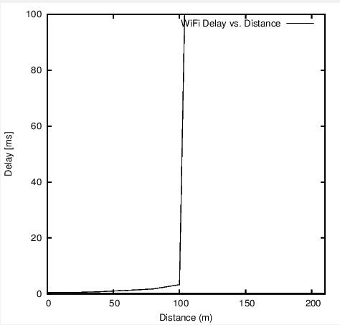

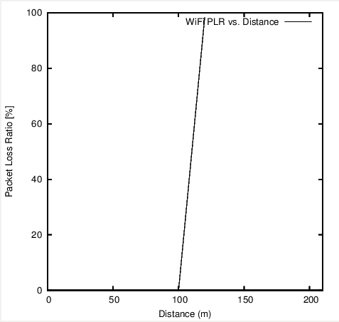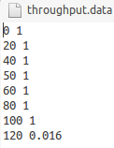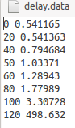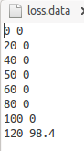

1. The example script is present in the Assignment_18210473/Question_C_2 directory. ./waf –run is used to run the example. The following example is implemented by adding users in the script **wifi-example-sim.cc**, maintaining the same bitrate for data traffic and maintaining the same distance from Access Point. By keeping the bitrate at 1Mbps of interval 0.008 the test is carried out for different number of users ranging from 1, 5, 10, 15 to 25 at different distances from AP (from 0 to 200 meters in steps of 20 meters). The example is carried for 1, 5, 10 and 15 users. The result after running script **wifi-example-sim.cc** is recorded in **DataOfUser1.db** file for the first user in **DataOfUser2.db** for 2nd user and this process is repeated until the Nth user. The performance parameters such as PLR, average throughput and average delay is calculated and observed for separate users and separate .db file is created for each user. The source code is attached below for each user example and the results and plots are stored in Zip folder and path is Assignment_18210473/ Question_C/ Question_C_2 directory.
2. Source code for 1 User



1. Source code for 5 Users



1. Source code for 10 Users



1. Source code for 15 Users



**PART 2: Results Comparison and Analysis**

* The example is simulated and analysed the data traffic using application NS3.26 and plotted the graphs and .db (database) files.
* When the bit-rate is changed in range 1Mbps, 5Mbps, 10Mbps, 15Mbps and 20Mbps; average throughput increases, and it is observed that the average PLR and average delay have subsequent increase as the bitrate is changed and increased.
* When the same example is tested at distances 0, 20, 40, 60, 80, 100….200 it is observed that after some distance loss i.e. PLR and delay increase, and throughput decreases. In the question 2 loss is 0 % up to 100m and increases to approx 96%.The same example is tested by adding 2nd user and it is observed that there is There is 0% packet loss ratio in data transmission for both users between distance 0-100m, average throughput is 1000 Kbps for both users. There is increase in average delay for user 2 as compared to user 1. However, it is seen that there is not much difference when you add 2nd user in the network.
* When the same example is tested by adding more users as demonstrated in question C for 1, 5, 10, 15-25 users it is observed as the number of users increases the delay and loss increases and throughput decreases.